Hello Student Pharmacist,

CVS Health, recognized for its innovation, is guided by values focused on teamwork, integrity and respect for our colleagues and customers. We will be on your campus looking for best-in-class talent with fresh ideas, new perspectives and a desire to make a real difference in one's career.

In addition to local positions, we will be featuring the following opportunities during our visit.  Please be sure to come see us, or connect with me or my colleagues at any time on LinkedIn or email to learn more!

* Northern California: Cara Healey – [Cara.Healey@cvscaremark.com](mailto:Cara.Healey@cvscaremark.com) or [https://www.linkedin.com/in/cara-healey-b059b098](https://na01.safelinks.protection.outlook.com/?url=https%3A%2F%2Fwww.linkedin.com%2Fin%2Fcara-healey-b059b098&data=01%7C01%7Csmm198%40pitt.edu%7Cb13d54a7ae884971d13708d504624b4f%7C9ef9f489e0a04eeb87cc3a526112fd0d%7C1&sdata=tE%2Fvj0kYNrc2XBeA8aP8IsIJhiL%2F9BiLIgblrNjn3WQ%3D&reserved=0)
* Washington DC: Kerry Cormier – [Kerry.Cormier@CVSHealth.com](mailto:Kerry.Cormier@CVSHealth.com) or [https://www.linkedin.com/in/kerry-cormier-cvshealth](https://na01.safelinks.protection.outlook.com/?url=https%3A%2F%2Fwww.linkedin.com%2Fin%2Fkerry-cormier-cvshealth&data=01%7C01%7Csmm198%40pitt.edu%7Cb13d54a7ae884971d13708d504624b4f%7C9ef9f489e0a04eeb87cc3a526112fd0d%7C1&sdata=xJH48wZc81iWwcTJRvRdzgUZVLuPSSDfv8SfxAFO8Pw%3D&reserved=0)
* Opportunities for Spanish Speaking Pharmacists: Scott Lason– [Scott.Lason@CVSHealth.com](mailto:Scott.Lason@CVSHealth.com) or [https://www.linkedin.com/in/scott-lason/](https://na01.safelinks.protection.outlook.com/?url=https%3A%2F%2Fwww.linkedin.com%2Fin%2Fscott-lason%2F&data=01%7C01%7Csmm198%40pitt.edu%7Cb13d54a7ae884971d13708d504624b4f%7C9ef9f489e0a04eeb87cc3a526112fd0d%7C1&sdata=xR6G7OK2CTA5f7ygpEEBTFAWYC3Mib8wTm2oEYDcx%2Fw%3D&reserved=0)

**Interviews**

All candidates interested in interviewing with CVS Pharmacy for intern or future pharmacist positions are required to complete an online application prior to the interview and also take an online Virtual Job Tryout as part of the application process.

* Applicants: Use instructions below.  Please create a profile and fill out any requested paperwork, including an application. If you have visited the site in the past and created a profile, you can use the same login email address previously provided.  Please complete the entire application process **at least 72 hours** prior to your scheduled interview.  **Note: Use an up-to-date Internet browser (e.g., Fire Fox, Chrome, Safari, or Internet Explorer) and apply from a computer.  Do not use a mobile device or tablet to apply.**

Application Instructions for applicants not currently employed by CVS Health

1. Visit [https://jobs.cvshealth.com/retail-pharmacy-internships](https://na01.safelinks.protection.outlook.com/?url=https%3A%2F%2Fjobs.cvshealth.com%2Fretail-pharmacy-internships&data=01%7C01%7Csmm198%40pitt.edu%7Cb13d54a7ae884971d13708d504624b4f%7C9ef9f489e0a04eeb87cc3a526112fd0d%7C1&sdata=2yZNB3Yd6uzi%2Bg2eGAFxGxPrLzY8%2BcPZY2c38neOHpE%3D&reserved=0) and select the Apply Now link
2. Click “Apply now- for Retail Pharmacy Internships”
3. Select “Click here to begin your application”
4. Select your pharmacy school and grad year and select “Submit”
5. This starts the application process.  You will simply move through each screen answering the questions.

CVS Health is an equal opportunity/affirmative action employer. Female/Minority/Disability/Protected Veteran – committed to diversity in the workplace.

**Attachment: Information on the Virtual Job Tryout for External Applicants**

If you are not a current or recent employee of CVS Health, as part of the application process you will be asked to complete a Virtual Job Tryout, or VJT. This exercise is designed to provide you with a realistic job preview and an opportunity to “try out” the job by completing exercises similar to those that colleagues in the Pharmacy Intern program perform on a day-to-day basis. In addition, you will be asked about your work history, motivators, and work style.

Below are answers to Frequently Asked Questions (FAQs) which provide more details about the VJT. We encourage you to review these FAQs and set aside up to an hour to complete the VJT in a quiet environment, free from distraction.

* *What is a Virtual Job Tryout (VJT)?*

The VJT is an interactive, online module of the application process that provides you a realistic job preview and asks you to provide information about your work history, work style preferences and your approach to problem solving and multi-tasking. It helps you and CVS Health determine if this job may be the right fit for you.

* *How do I take the VJT?*

When you fill out an online application for a Pharmacy Intern role, the application will automatically direct you to the VJT. You will see the following screen:

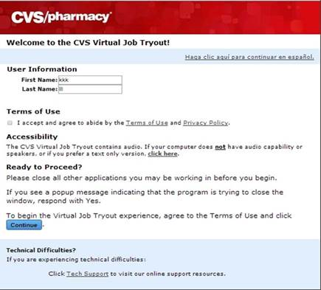

You must enter your first and last name, agree to the Terms of Use, and click on the “Continue” button to take the VJT.

If you have trouble getting into the application, make sure you are using a PC or tablet (the VJT is not mobile compatible). For other issues, contact the VJT Help Desk at 1-877-987-5352 (8:00 a.m. to 8:00 p.m. ET, 7 days a week).

* *How long do I have to complete it?*

The VJT is not a timed test. You have as much time as you need. There is *one* section in the Pharmacy Intern VJT in which speed is a part of the score for that section. That said, the system will not cut you off – the test will not “time out” no matter how long you take.

* *Do you offer accommodations to take the test?*

The VJT was developed according to universal design principles so that accessibility is optimized. For example:

* The font size and color contrast maximizes visual clarity
* It is not timed, so you can work at a pace that is comfortable to you.
* The default setting is text and audio. However, you can take a text only version.
* It is also offered in English or Spanish.

That said, if you need to request an accommodation, contact at 1-877-987-5352 (8:00 a.m. to 8:00 p.m. ET, 7 days a week).

* *What if I don’t have time to take it (or finish it) ?*

If you don’t have time to continue with the VJT, you may click on the “Exit” button. You will receive the following message:

You have not completed the Virtual Job Tryout. Are you sure you want to EXIT?

To log back in, use the link that was emailed to you. If you have not yet received your email, it should arrive within 24 hours.

Look for the email reminder with link in your inbox at least 24 hours after you initially exited out of the system. Some email providers filter out emails that are generated from another application, so if you do not see the email, check your spam or junk folder.

* *What does the VJT look like?*

The Pharmacy Intern VJT consists of six exercises which are described in more detail below. Note that when you are online and completing the VJT, instructions and example items are provided. In most cases, situations and scenarios presented reflect those that are typical for a retail pharmacy. However, you do not need previous experience to successfully complete the VJT.

**Realistic Job Preview**

This is the lengthiest exercise in the VJT. In it, a Pharmacy Intern describes what the work is like, including typical tasks, the environment of a retail pharmacy, and the challenges and rewards of the work.

**Working with Patients**

This exercise simulates scenarios like those a Pharmacy Intern faces on the job. You are presented with four possible responses and you must indicate select one which represents how you are most likely to respond – and the one you are least likely to respond.

Note that this is not a multiple choice question with one correct response. All responses are possible and you must make two selections – the one you would MOST likely respond and the one you would LEAST likely respond.

**Accuracy Checking**

In this exercise you will be presented with different tasks related to entering and checking prescriptions. You will be asked to enter prescription data accurately or verify that data presented is accurate.

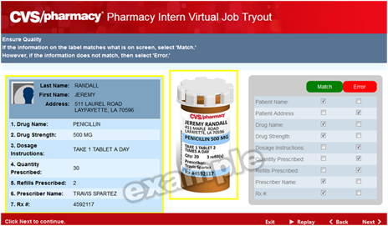

**Drivers**

This exercise asks about the type of work environment factors that motivate you. You will be presented with two statements and asked to indicate which statement reflects what you would value more in a job.

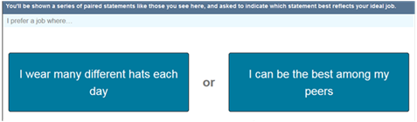

While you may see the same statement more than once, you will not see the same *pair* of statements more than once.

**Work Styles**

This exercise asks you about your preferred approach to work, or work style. It presents of a series of paired statements and you will compare them and indicate not only which statement is more like you, but *the extent to which* the statement is like you.

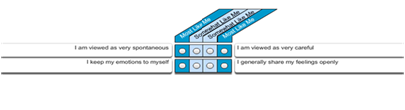

**Tell us Your Story**

This exercise asks you to describe your previous experience. If you do not have previous employment experience, use your experiences in academic, sports, and/or other community settings.

* *When will I get my score?*

CVS Health does not provide scores to applicants. The VJT is one of many sources of information that we use to screen and prioritize applicants. Therefore, how well an applicant performs does not guarantee an opportunity to interview or job offer. For example, depending on the pool of candidates who apply for a given job, applicants who score strongly may not receive a job offer while, in other situations, applicants who score moderately will receive a job offer. Other factors of consideration are schedule availability, work history, criminal background check, and interview performance.  If you do not receive an invitation to interview or an offer of employment, we encourage you to monitor our openings and try again in six months.